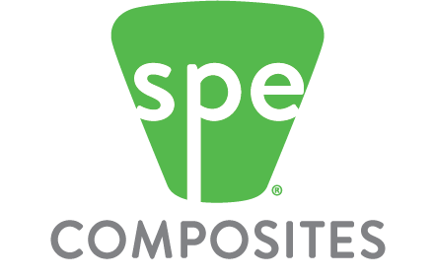
CALL FOR NOMINATIONS
SPE COMPOSITES DIVISION
COMPOSITES EDUCATOR OF THE YEAR 2019
Submission Deadline: January 15, 2019

The Composites Division of the Society of Plastics Engineers is pleased to announce that it has begun accepting nominations for the COMPOSITES EDUCATOR OF THE YEAR 2019. The winner receives a plaque and a cheque for $2500 at ANTEC.

The COMPOSITES EDUCATOR OF THE YEAR is someone in the educational field (high school, university, or college-level) who has made a significant contribution to the training of students in the composites area. Examples of contributions would include the creation of new educational programs, the development of new pedagogical tools, and motivating students to enter the composite sector. It will be primarily based on contributions made during the 2018 calendar year.

To participate please submit: (1) the attached nomination form, (2) two letters of support for the nominee. Send the completed application to Dr. Dale A. Grove (grove.dale@hotmail.com) before January 15, 2019. Judging will be done by industry members of the SPE Composite Division’s Board of Directors.

SPE Composite Division Educator of the Year 2019 Application Form
Nominated educator (name, position, institution, telephone number, email address)
Reason for nomination (250-500 words)
Reference #1* (name, position, institution, telephone number, email address)  Each reference must write a one-page letter of support explaining how the nominee has made a significant contribution to the training of students in the composites area in 2018. | Reference #2 (name, position, institution, telephone number, email address)  Each reference must write a one-page letter of support explaining how the nominee has made a significant contribution to the training of students in the composites area in 2018.
* This person can also be the nominating person.

Submission Deadline: January 15, 2019

